# TITLE OF PROJECT

AURORA - A BLOGGERS' SPOT

**A Project Report**

***Submitted by***

**Aditi Gupta B035**

**Ishaan Almeida B007**

**Hrishikesh Balaji B010**

***Under the Guidance of***

Prof. Vijayetha Thoday

***in partial fulfillment for the award of the degree of***

## B. Tech (Computer Engineering)

At



**MPSTME, Mumbai**

**Nov, 2020**

## DECLARATION

I, **Aditi Gupta,**  Roll No. **B035**, B. Tech (Computer Engineering), V semester understand that plagiarism is defined as anyone or combination of the following:

1. Un-credited verbatim copying of individual sentences, paragraphs or illustration (such as graphs, diagrams, etc.) from any source, published or unpublished, including the internet.
2. Un-credited improper paraphrasing of pages paragraphs (changing a few words phrases, or rearranging the original sentence order)
3. Credited verbatim copying of a major portion of a paper (or thesis chapter) without clear delineation of who did wrote what. ( Source: IEEE, The institute, Dec. 2004)
4. I have made sure that all the ideas, expressions, graphs, diagrams, etc., that are not a result of my work, are properly credited. Long phrases or sentences that had to be used verbatim from published literature have been clearly identified using quotation marks.
5. I affirm that no portion of my work can be considered as plagiarism and I take full responsibility if such a complaint occurs. I understand fully well that the guide of the seminar/ project report may not be in a position to check for the possibility of such incidences of plagiarism in this body of work.

Names: Aditi Gupta, Hrishikesh Balaji, Ishaan Almeida

Roll Nos. : B035, B010, B007

Place: Mumbai

Date: 3/11/2020

## CERTIFICATE

This is to certify that the project entitled “Aurora- A Blogger’s Spot” is the bonafide work carried out by **Aditi Gupta** of BTech, MPSTME (NMIMS), Mumbai, during the IV semester of the academic year 2020-21, in partial fulfillment of the requirements for the Course Programming Language.

___________________

Prof. Vijayetha Thoday

Internal Mentor

_______________________ ________________________

Examiner 1 Examiner 2

## Table of contents

## 

**CHAPTER NO. TITLE PAGE NO.**

1. PROJECT INTRODUCTION 1
2. MODULES IMPLEMENTED 2
3. SCREENSHOTS 3
4. CONCLUSION & FUTURE SCOPE 9
5. SOCIETAL APPLICATION (If any) 10

**Project Introduction**

In this project, we built a website where people of all ages can upload posts in the form of blogs, articles, poems and photographs. Informal articles are written and shared here for the purpose of showing thought leadership and expertise on a topic. This is a great way to generate fresh content. It is a great platform to communicate via posts. We can also use this as a site to host images to showcase photography skills. Posting regular, valuable content creates trust with your connections and helps you to be seen as an expert on your topic.

This website was built using HTML, CSS, JQUERY AND PHP. It has multiple functionalities such as to upload photos, articles and poems which then appears on a side bar as an index. A decent template was made for the same from scratch using various CSS tags in HTML. Databases were created to store user login information as well as the posts a user uploads on the webpage and were accessed with the help of PHP. Overall, the website/project is a virtually accurate representation of a website that would be implemented as a bloggers’ platform.

**Modules Implemented**

**1. HTML**: is the standard markup language for documents designed to be displayed in a web browser. It can be assisted by technologies such as Cascading Style Sheets (CSS) and scripting languages such as JavaScript.

**2. CSS**: is a style sheet language used for describing the presentation of a document written in a markup language such as HTML.

**3. JavaScript/jQuery**: It is used for form validation and to perform certain functions as the user clicks on certain components of the webpage making it a interactive webpage.

**4. PHP:** It is used as server scripting language which communicates with MySQL database.

**5. MySQL**: is used as database to store user details and their uploaded material.

**Screenshots**

HOME

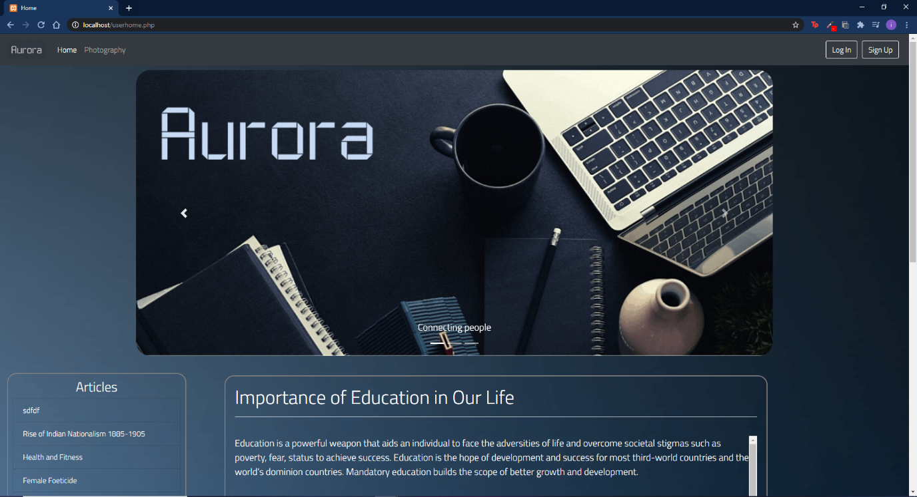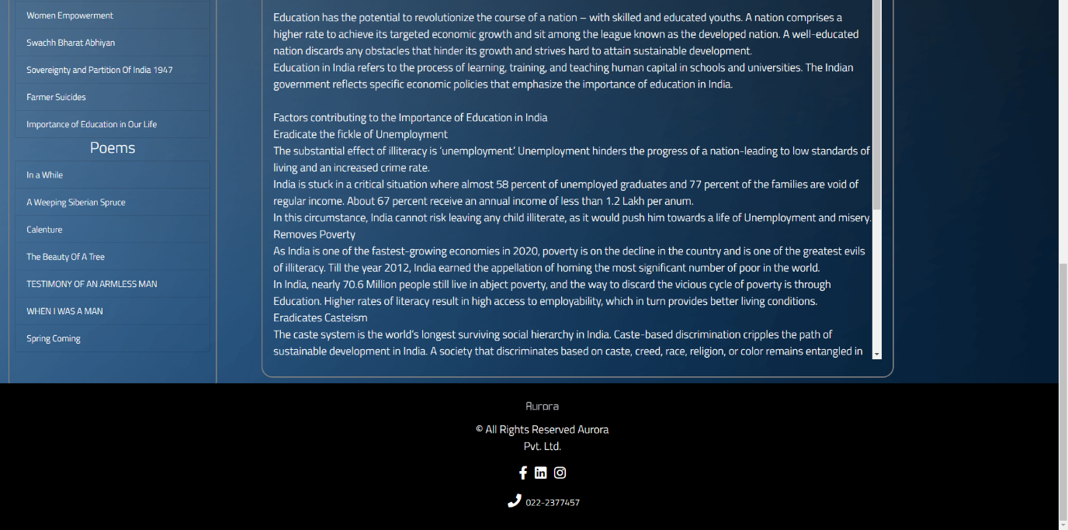

PHOTOGRAPHY

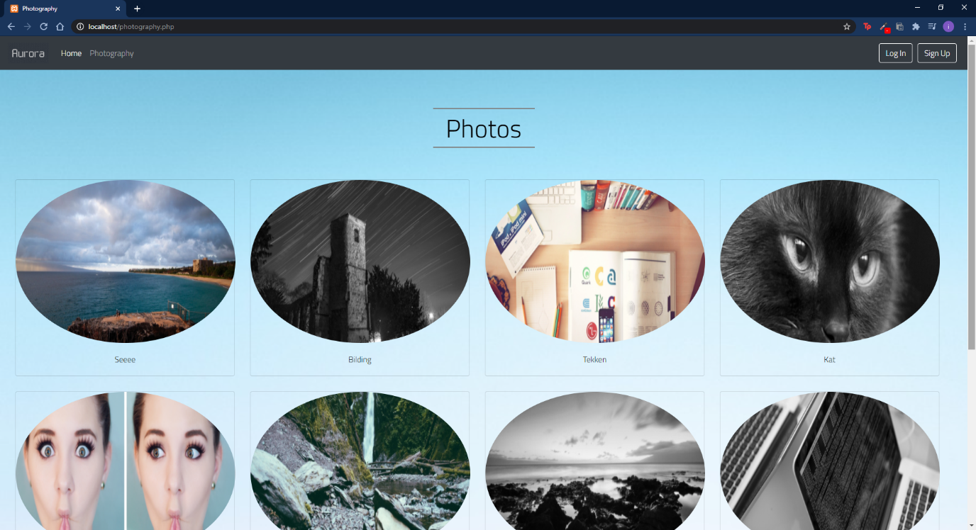

SIGN UP

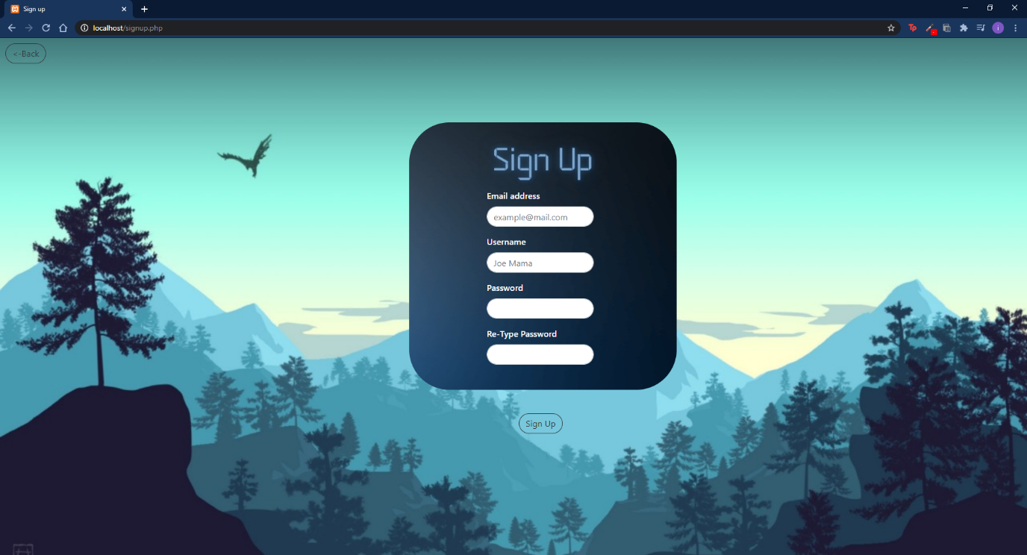

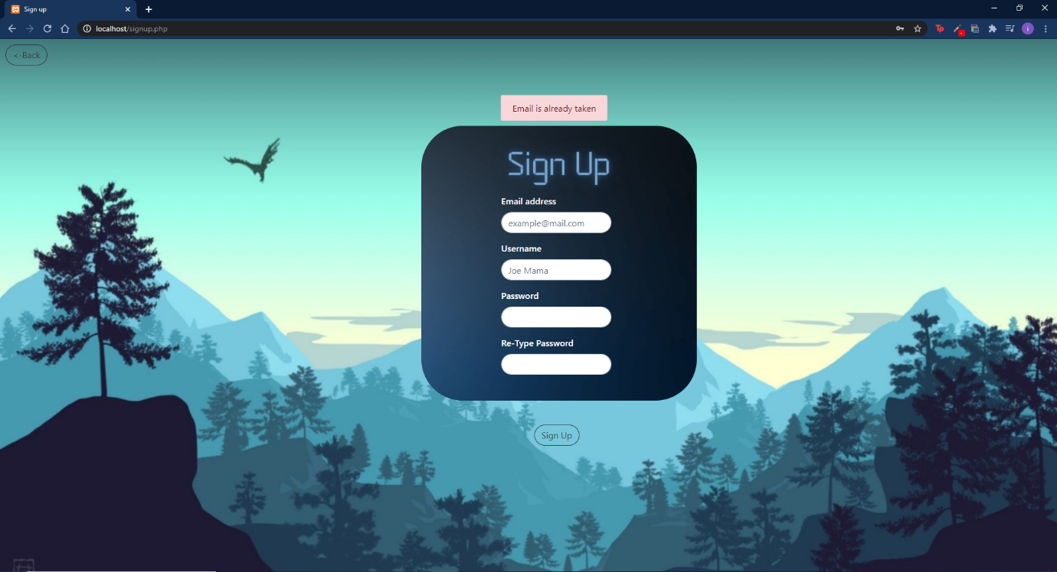

LOG IN

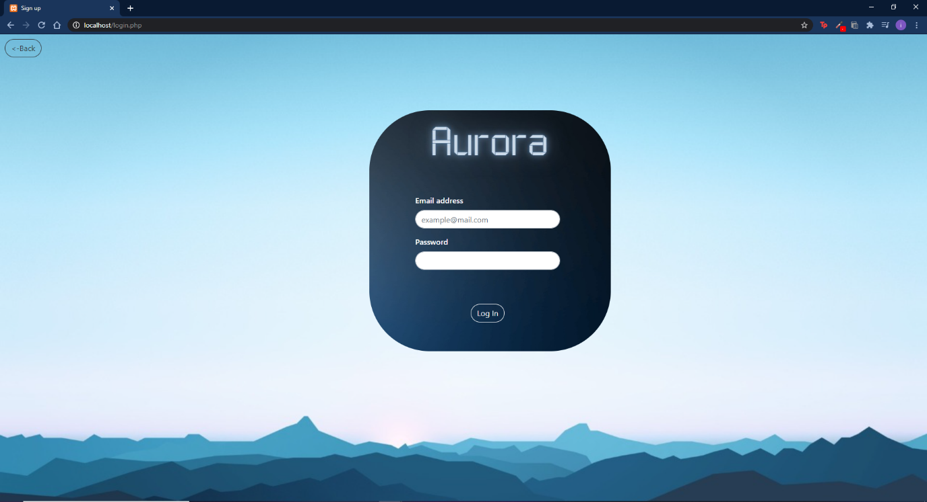

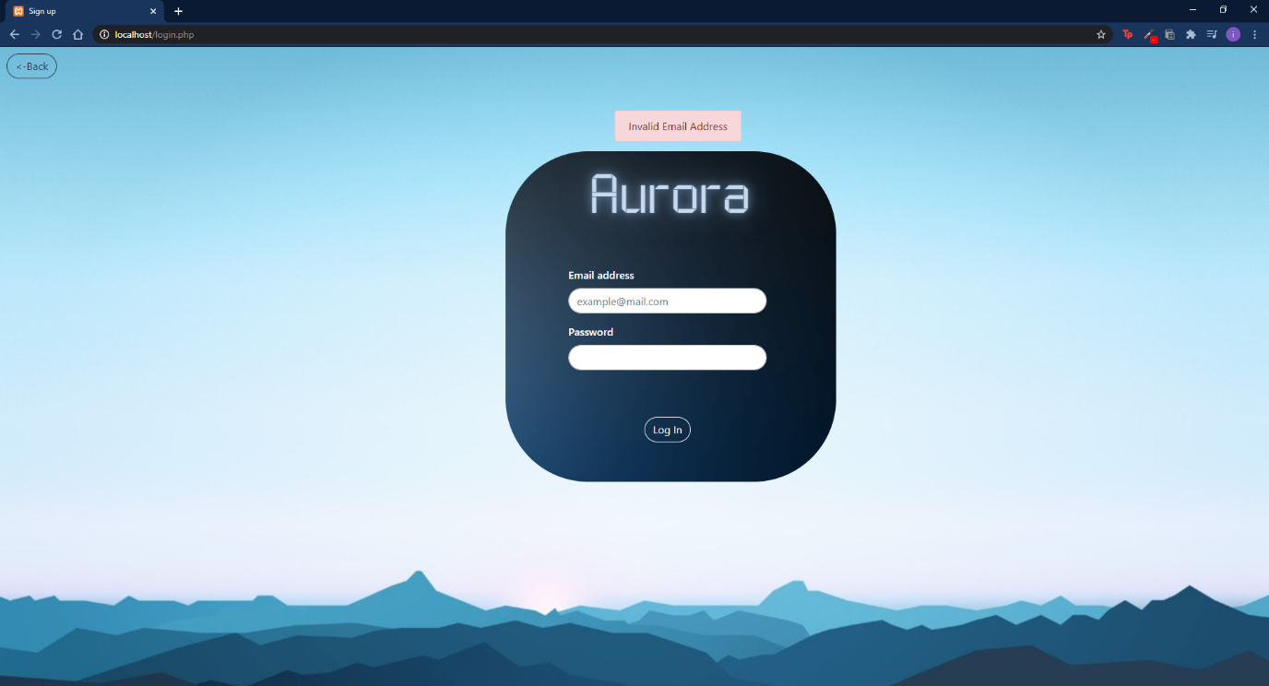

HOMEPAGE AFTER LOGGING IN (navbar has changed)

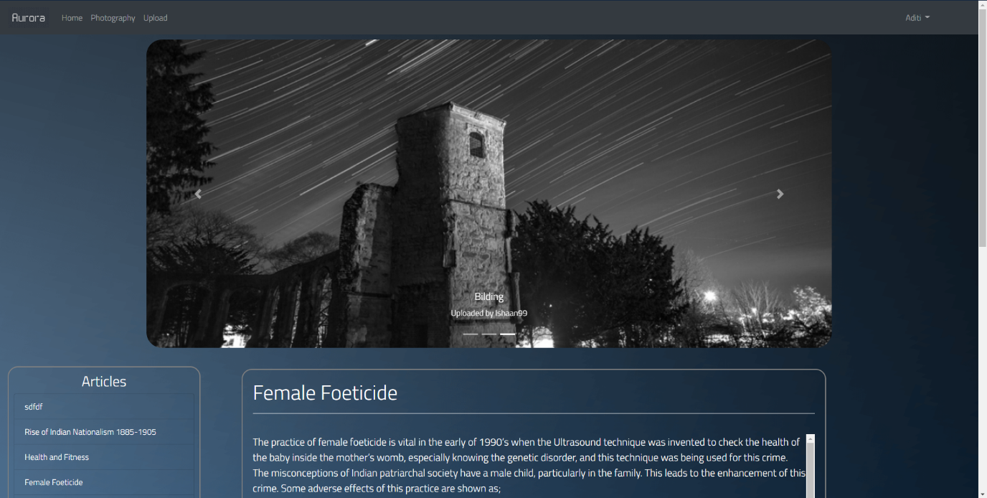

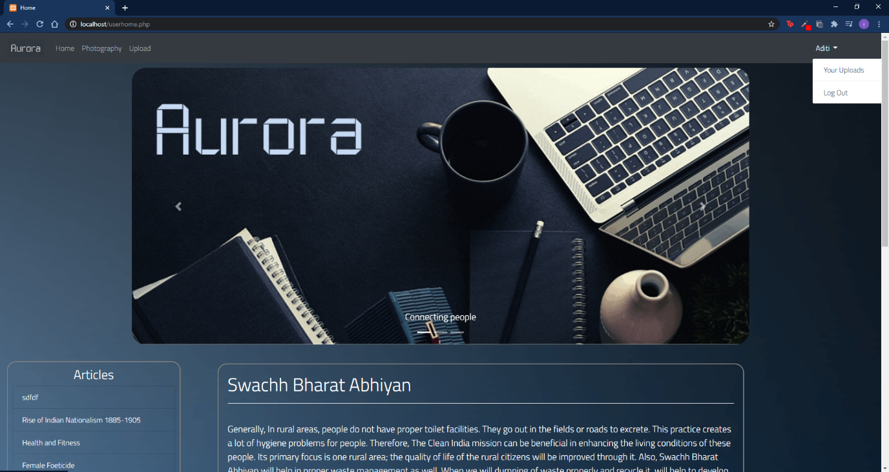

UPLOAD

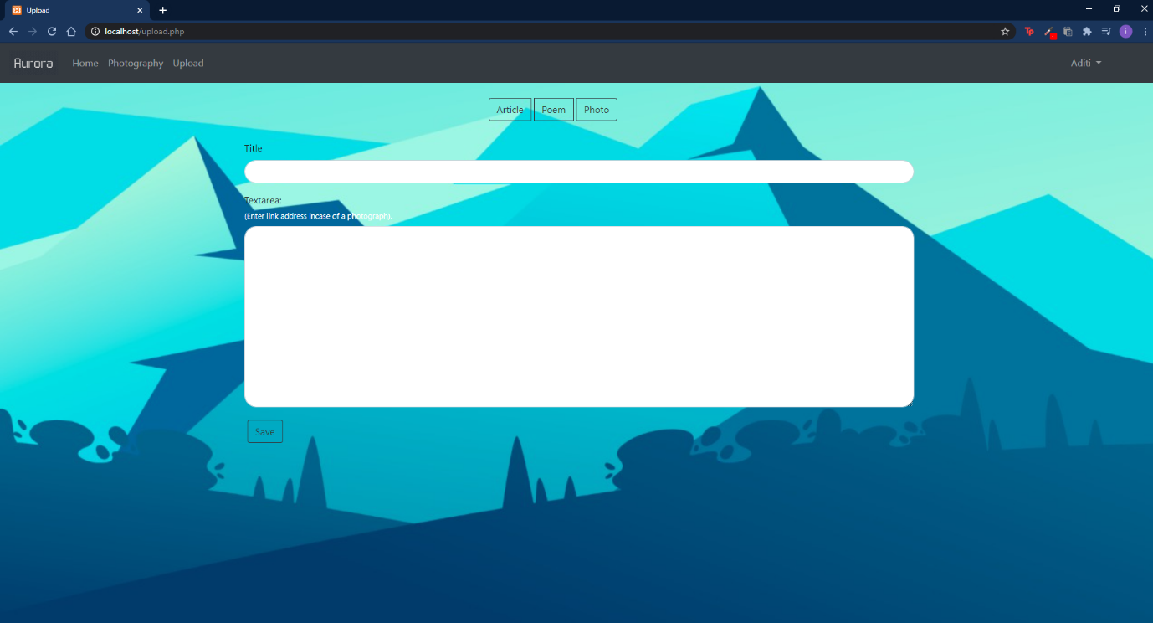

YOUR UPLOADS  
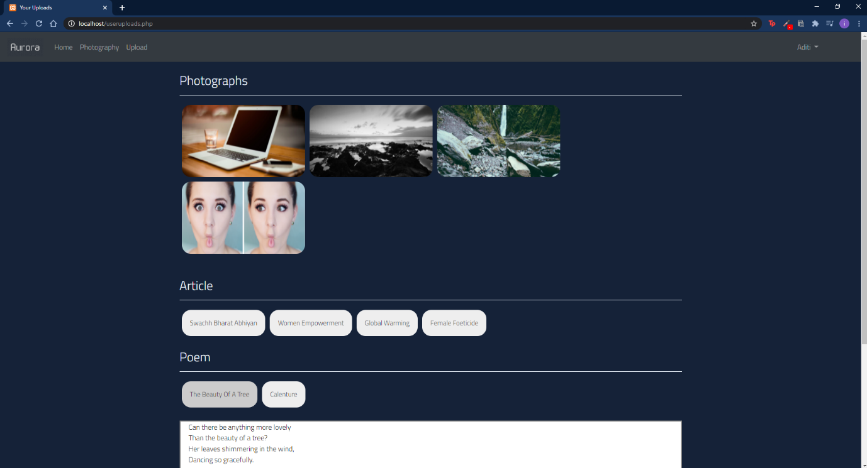

**Conclusion and Future Scope**

The project employs HTML, CSS, PHP, jQuery, and MySQL. It provides a range of functionalities to the user. The functions include having a login page for the user, a homepage to review all posts made by the user themselves and other users too, a registration page for new users, and a page from where the user can upload his work. To conclude, this project encompasses all aspects that could be required for a website as a bloggers’ spot.

Further the project can be enhanced by adding various other features such as an option to like, comment and post reviews on articles and blogs by other users. Also, certain types of articles can be restricted from being posted using a php database which contains of words/phrases which shouldn’t be included in posts and offend a community of people. Basically various additional features can be included if we work on the same in the future.

**Societal Applications**

This is an easy-to-use and fairly feature-rich blogging application that is completely free to all. It can be used as a way to connect people’s thoughts and share their ideas regarding similar topics. It is a great way to get in touch with other’s write ups and posts.